**3/3/25 AEM LOCAL SETUP**

**Day 1**

CREATED SEPARATE FOLDERS FOR AEM JAR DOWNLOAD AND CODEBASE

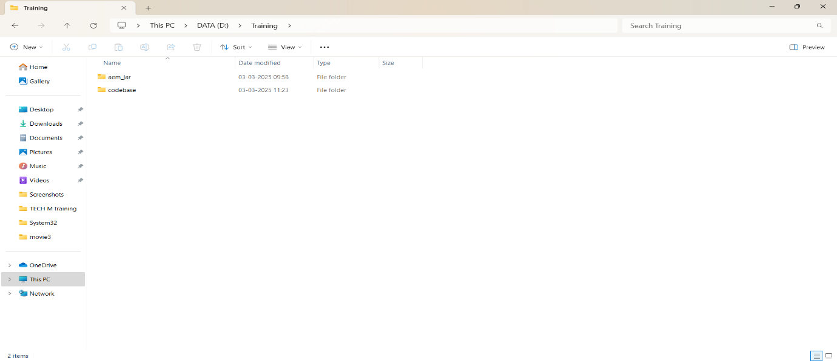

JDK 11 ,MAVEN INSTALLATION AND AEM JAR FILE

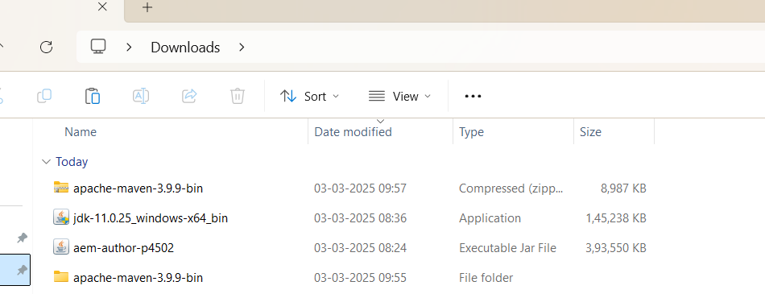

INSIDE AEM JAR FOLDER

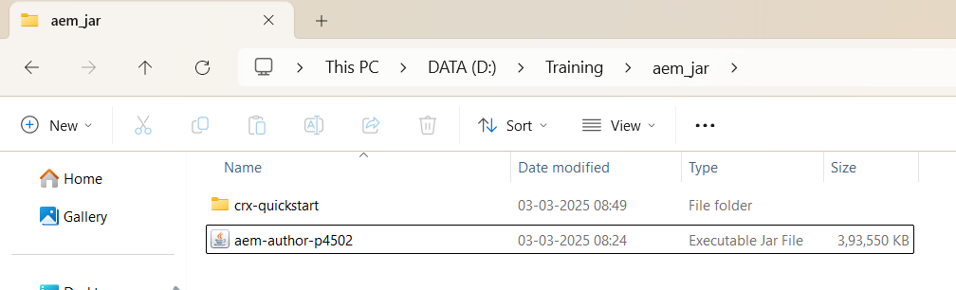

OPENING AEM

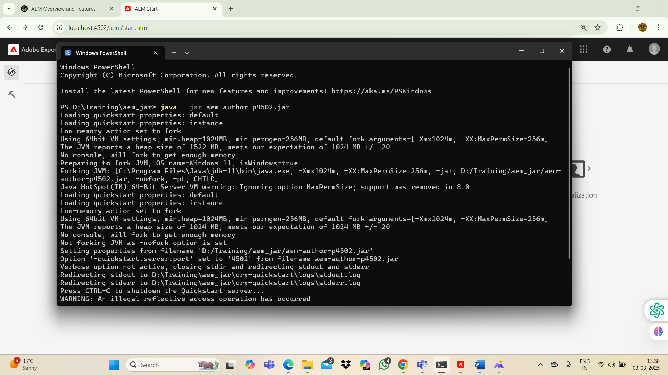

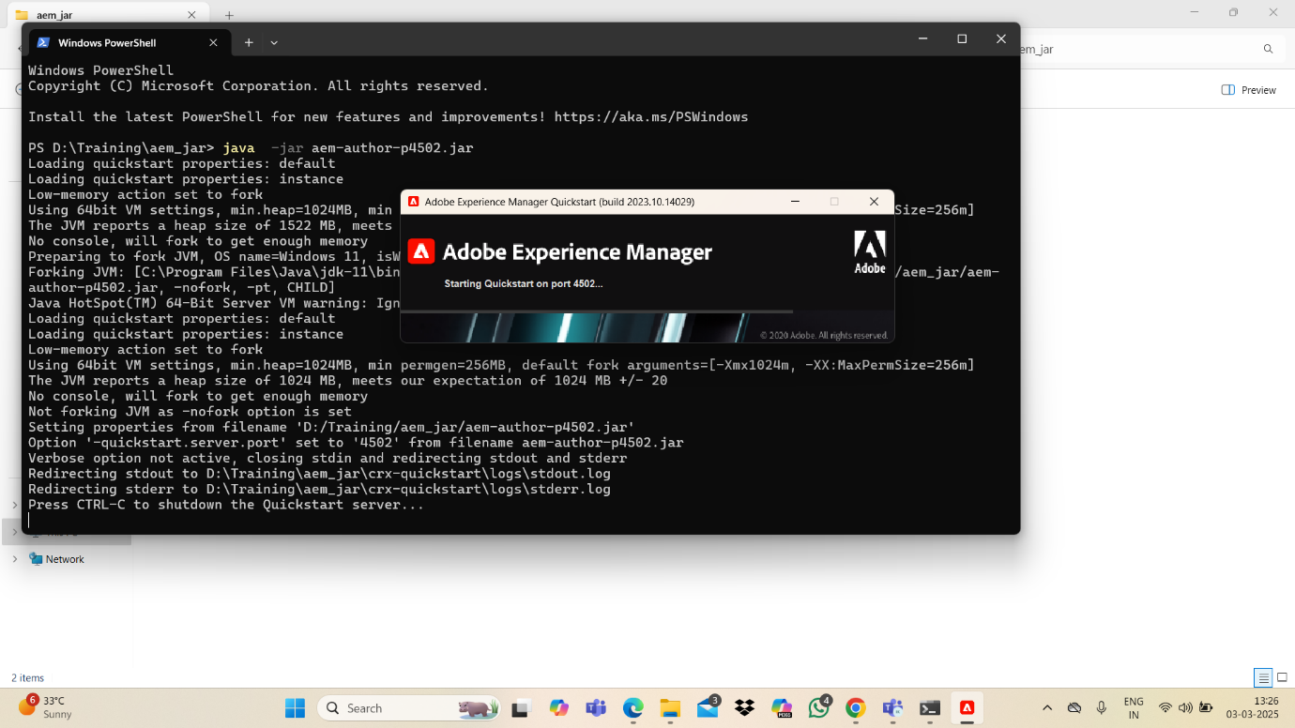

USERNAME-admin

PASSWORD-admin



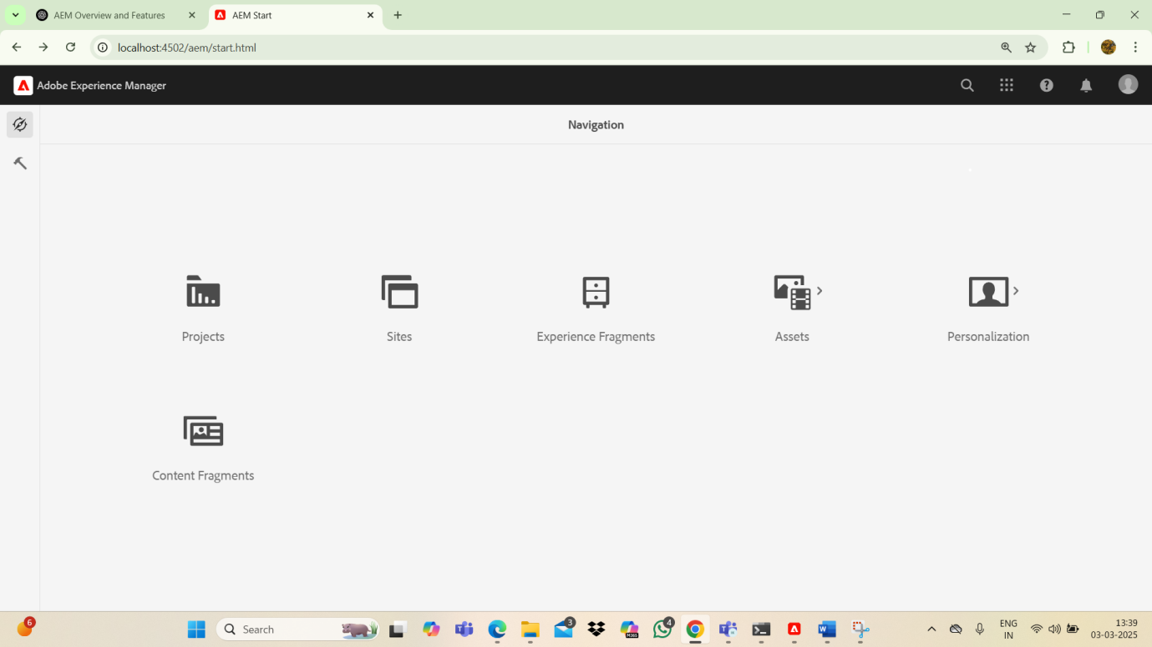

AFTER EXECUTING -

mvn -B org.apache.maven.plugins:maven-archetype-plugin:3.2.1:generate -D archetypeGroupId=com.adobe.aem -D archetypeArtifactId=aem-project-archetype -D archetypeVersion=39 -D appTitle="myTraining" -D appId="myTraining" -D groupId="com.myTraining" -D aemVersion=6.5.5 -D includeExamples=n -D includeErrorHandler=y

**GOT BUILD SUCCESS**

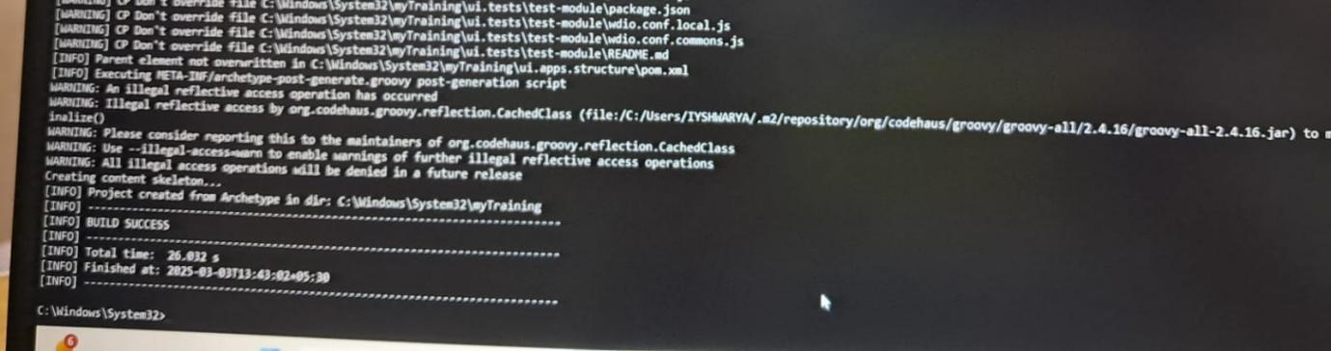

PROJECT STRUCTURE GOT CREATED INSIDE CODEBASE FOLDER

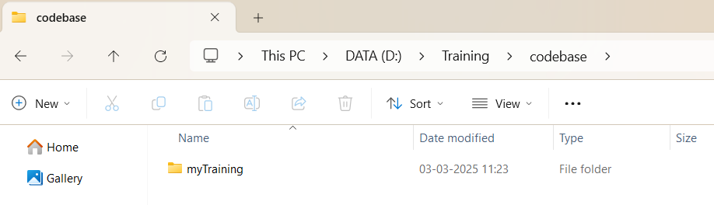

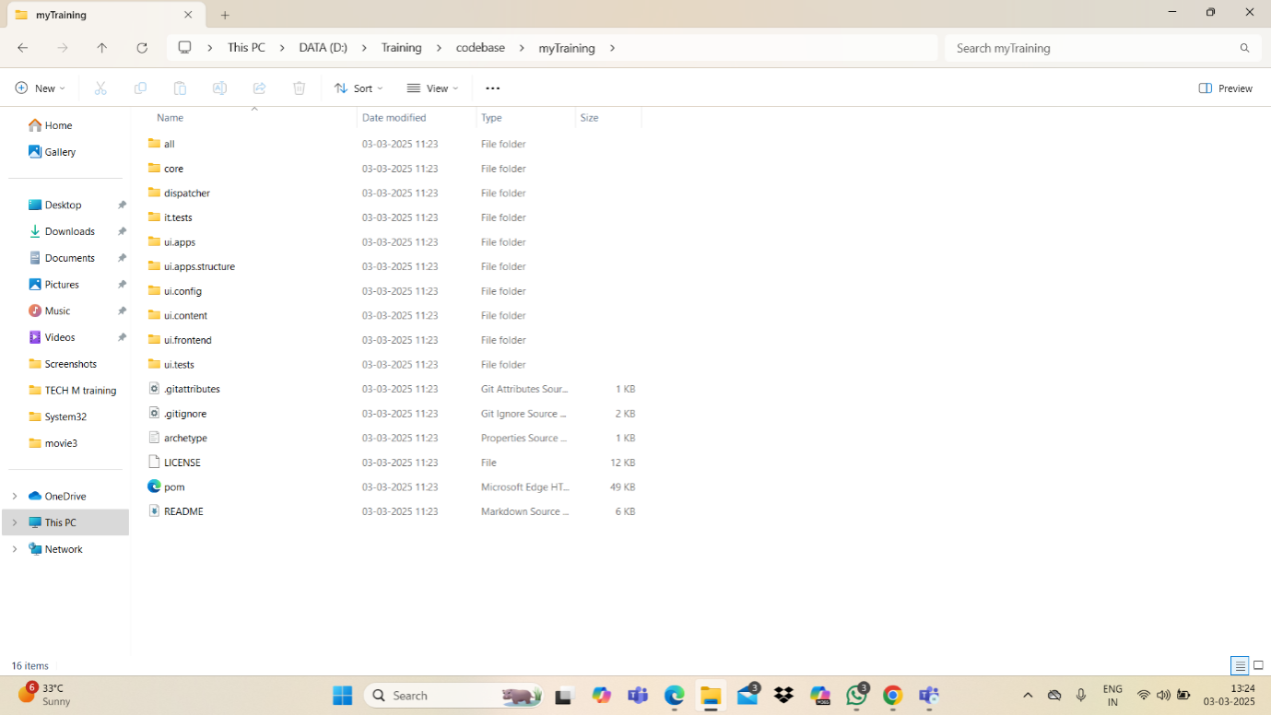

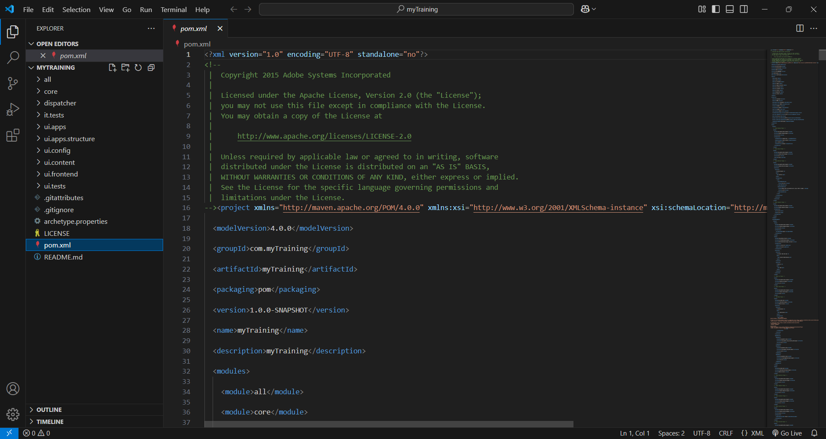

IYSHWARYA K